
Live Tool Lathe

Drilling and Tapping

Y-Axis Lathe Training

Main Spindle, Live-Tooling, Secondary-Spindle

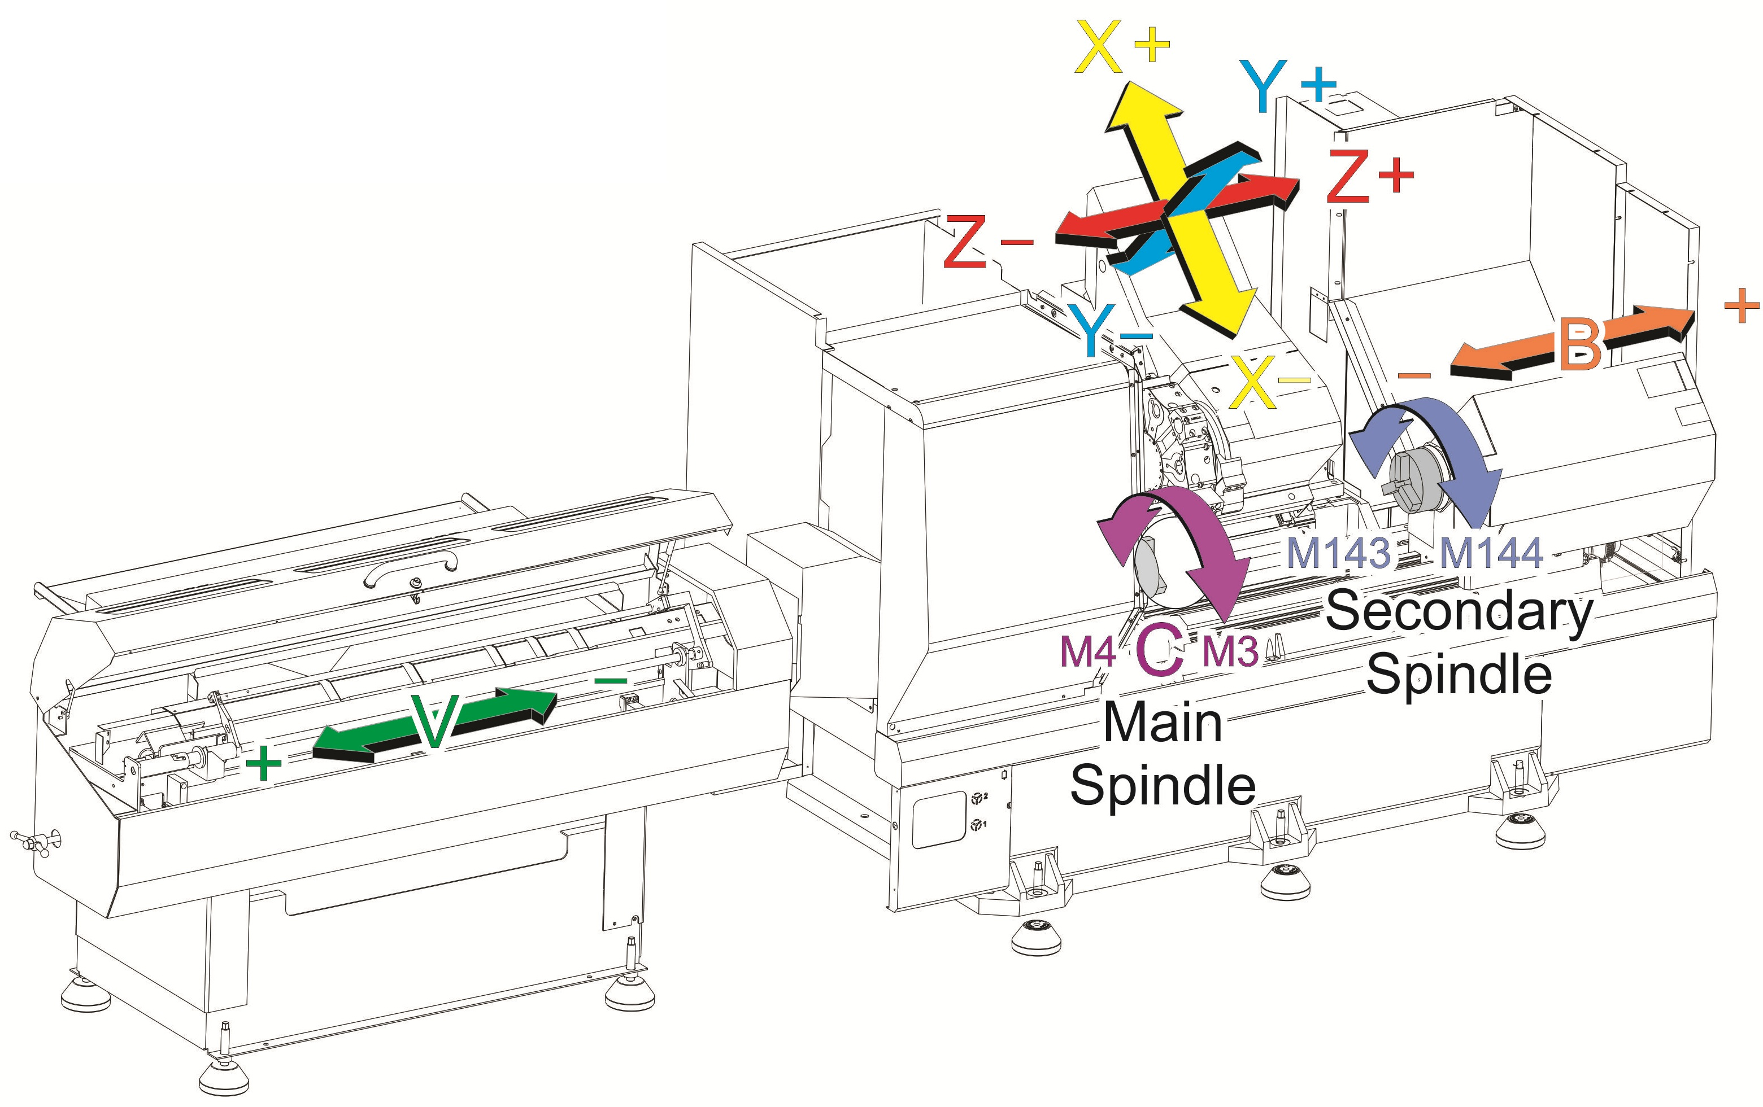


Live-Tooling Drilling and Tapping Overview


Which axis? X, Z?

What is spinning? Main Spindle, Secondary Spindle, Live Tooling?

Which way does it spin? Clockwise, Counter-Clockwise?
What RPM is it spinning at? P or S Command?
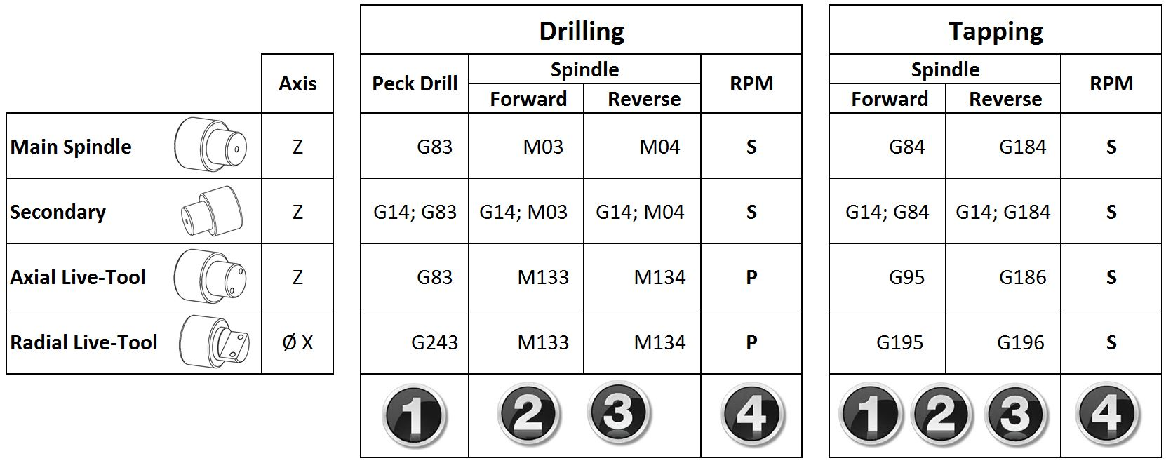

- Always Verify Live-Tool rotation visually. Gearing may reverse direction.
- Applies to Live-Tool Lathes built after 6/2012, with Lathe Software L11.06 and newer.

LIVE-TOOL CANNED CYCLES
CHANGES BETWEEN VERSIONS

Running L11.02 or newer?
Use the G18 plane for all of your Axial and Radial live-tool drilling/tapping/boring canned cycles.
Use only designated Radial Canned Cycles (i.e., G241) for drilling/tapping/boring radially.

The Haas lathe uses different G codes for Axial and Radial Canned Cycles.

To Peck Drill axially (in the Z direction), we will use a G83. To Peck Drill radially (along the X-Axis), we will use a G243. Both the G83 (axial) and G243 (radial) Peck Drill Canned Cycles are called using the G18 plane.

Prior to L11.06 it was possible to force a G83 (or similar) canned cycle to cut radially instead of axially by changing the plane from a G18 to a G17. Since L11.06 the control will ignore all plane call-ups, and will run Axial Cycles along the Z-Axis only and Radial Cycles along the X-Axis only.

Designated Radial Canned Cycles (G241-249, G195-196) were made usable in L11.02. These cycles will always cut along the X-Axis, regardless of plane selection.

Live-Tooling Lathes with software older than L11.02 must use the default G18 plane to drill axially, and the G17 plane to drill Radially (O.D.).

Many changes have been made to our Lathe Manual recently. Be sure to download the latest revision.

Axial Cycles: G81, G82, G83, G85, G86, G87, G88, G89, G95, and G186

Radial Canned Cycles: G195, G196, G241, G242, G243, G245, and G249

AXIAL CANNED CYCLES

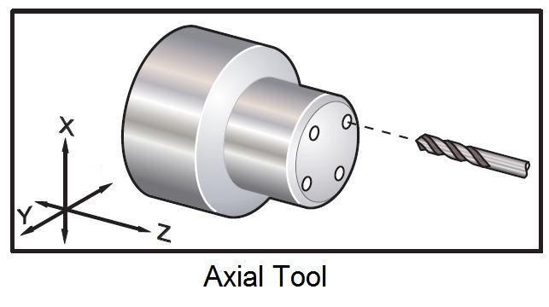

Below are our Axial Canned Cycles, as listed in the manual (96-8700 Rev AN April):

Axial Cycles:
G81 Drill Canned Cycle (Group 09)
G82 Spot Drill Canned Cycle (Group 09)
G83 Normal Peck Drilling Canned Cycle (Group 09)
G85 Boring Canned Cycle (Group 09)
G86 Bore and Stop Canned Cycle (Group 09)
G87 Bore and Manual Retract Canned Cycle (Group 09)
G88 Bore and Dwell and Manual Retract Canned Cycle (Group 09)
G89 Bore and Dwell Canned Cycle (Group 09)
G95 Live Tooling Rigid Tap (Face) (Group 09)
G186 Reverse Live Tool Rig Tap (For Left Hand Threads) (Group 09)

Refer to the Lathe Manual for detailed descriptions of these cycles. The manual has been updated, and contains the latest information on these cycles.

In order to use Live Tool Canned Cycles, Parameter 315, Bit 1, NO SPIND CAN needs to be set to “1”.

It is always best to use the M154 (C-Axis) to orientate the Main Spindle, as opposed to using an M19. This is a much more accurate and repeatable method. The Secondary Spindle on a DS machine has no C-Axis, and indexing on that spindle must be commanded with an M119, or a G14 M19. See the Dual Spindle section for more information.

The following axial drilling example will work on all software versions:

Axial Cycle Example:
%
O00810 (G81- AXIAL DRILLING)
T2323
G54 G18 G98(USE G18 PLANE)
M154 (Engage C-Axis)
G00 X6. C0. Z1.
G00 X2. Z0.25
G97 P1500 M133
G81 G98 X1. Z-1. F10.
C135. (DRILL SECOND HOLE AT C135.)
G00 G80 Z0.25
M155
M135
M09
G28 H0. (Unwind C-Axis)
G00 X6. Z1.
M30
%

See below for programming examples.

RADIAL CANNED CYCLES

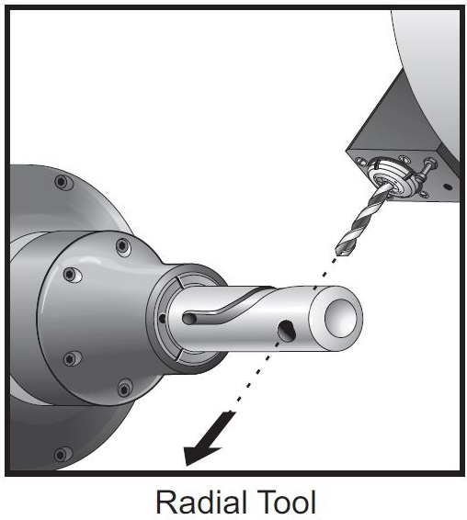

Radial Canned Cycles:
G195 Forward Live Tool Radial Tapping (Diameter) (Group 00)
G196 Reverse Live Tool Radial Tapping (Diameter) (Group 00)
G241 Radial Drill Canned Cycle (Group 09)
G242 Radial Spot Drill Canned Cycle (Group 09)
G243 Radial Normal Peck Drilling Canned Cycle (Group 09)
G245 Radial Boring Canned Cycle (Group 09)
G249 Radial Bore and Dwell Canned Cycle (Group 09)

Refer to the Lathe Manual for detailed descriptions of these cycles. The manual has been updated, and contains the latest information on these cycles.

It is always best to use the M154 (C-Axis) to orientate the Main Spindle, as opposed to using an M19. This is a much more accurate and repeatable method. The Secondary Spindle on a DS machine has no C-Axis, and indexing on that spindle must be commanded with an M119, or a G14 M19. See the Dual Spindle section for more information.

The G195 radial tapping cycle is unique, and differs from other canned cycles. See the current manual for a full description.

The tool must be positioned to the Start Point before commanding G195/G196. This G code is called for each hole being tapped. The cycle begins from the current position, tapping to the X-axis depth specified. An “R” plane is not used. Only X and F values should be used on G195/G196 lines. The tool must be positioned to the Start Point of any additional holes before commanding G195/G196 again.

Program Example
%
O01950 (LIVE TAP - RADIAL)
T101
M154 (Engage C-Axis)
G00 G54 X6. C0. Y0. Z1.
G00 X3.25 Z-0.75 C0. Y0. (Start Point)
G99 (Must Set to Feed Per Rev. for this cycle)
S500
G195 X2. F0.05 (Taps to X2., bottom of hole)
G00 C180. (Index C-axis. New Start Point)
G195 X2. F0.05
G00 C270. Y-1. Z-1. (Optional Y and Z-axis positioning, New Start Point)
G195 X2. F0.05
G00 G80 Z0.25
M135
M155
G00 G28 H0. (Returns C-axis to Home Position)
G00 X6. Y0. Z3.
G98
M30
%

While not shown above, the G195 cycle can be used to Vector Tap along the X and Z axes. Vector tapping using the Y axis is not allowed.

Program examples for each of the Radial Canned Cycles, can be found at the end of this document.

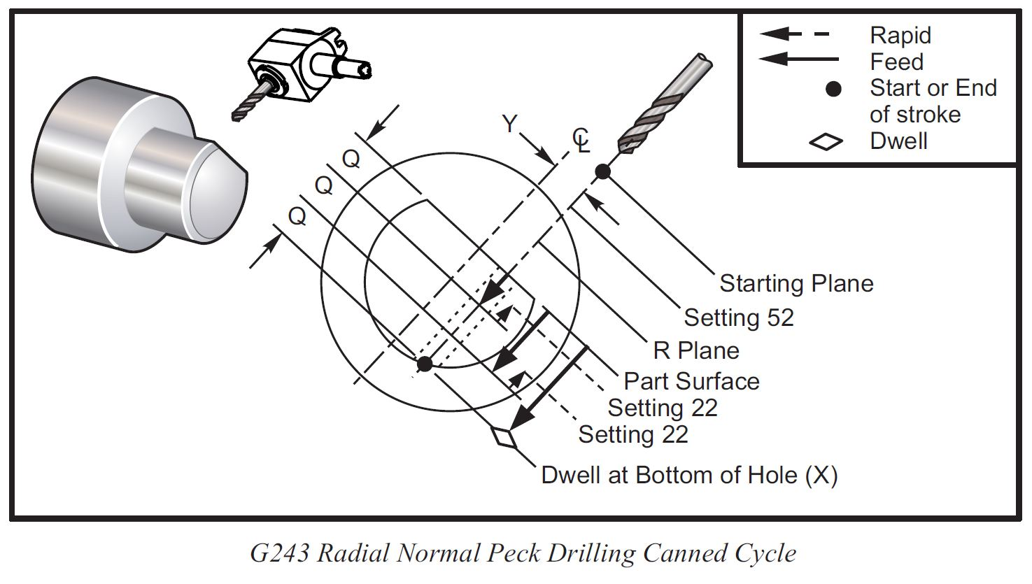

The following is a typical G243 Radial Normal Peck Drilling Canned Cycle:

(G243 - RADIAL PECK DRILLING USING Q)
G54 (Work offset G54)
G00 G53 Y0 (Home Y-axis)
G00 G53 X0
G00 G53 Z0
T303
M154 (Engage C Axis)
M133 P2500 (2500 RPM)
G98 (IPM)
G00 X5. Z-0.75 Y0
G243 X2.1 Y0.125 Z-1.3 C35. R4. Q0.25 F20. (Drill to X 2.1)
X1.85 Y-0.255 Z-0.865 C-75. Q0.25
G00 G80 Z1.
M135 (Stop live tool spindle)
G00 G53 Y0
G00 G53 X0
G00 G53 Z0
M00

For all machines with L11.02 or newer, use the new Radial Canned Cycles (G195-249).

For L11.01 machines and older, you can use standard axial canned cycles to drill radially, by changing the plane from G18 to G17, and changing your depths from a Z to an X diameter value.

The following radial drilling example is only to be used if you have version L11.01 or older.

%
O00831 (G83 - RADIAL PECK TEST)
(THIS PROGRAM DRILLS RADIALLY)
(IT IS ONLY VALID ON SOFTWARE)
(VERSIONS L11.01 AND OLDER)
(FOR L11.02 AND NEWER, USE G243)
G54
G53 G00 Y0.
G53 G00 X0.
G53 G00 Z-7.
T505 (DRILL)
G18
G98
M154 (Engage C-Axis)
G00 G54 X6. C0. Z1.
G00 X6. Z0.25
G97 P1500 M133
(M08)
(SWITCH TO G17 FOR RADIAL ON OLDER LATHE)
(THE DEPTH IS AN X VALUE, FOR RADIAL)
G17 G83 G98 X1. I1. J0.5 K0.5 R5. F10.
C135.
C225.
G00 G80 Z0.25
M155
M135
M09
G18 (RETURN TO G18)
G28 H0. (Unwind C-Axis)
G00 G53 Y0.
G00 G53 X0.
M30
%

AXIAL LIVE-TOOL CANNED CYCLES

Axial Live-Tool Canned Cycles: G81, G82, G83, G85, G86, G87, G88, G89, G95, and G186

G81 DRILL
AXIAL

%
O00810 (G81 AXIAL LIVE-TOOL)
(AXIAL FACE DRILL TEST)

G53 G00 Y0.
G53 G00 X0.

T2323
G18
G98
M154 (Engage C-Axis)
G00 G58 X6. C0. Y0. Z1.
G00 X2. Z0.25
G97 P1500 M133
(M08)
G18 G81 G98 X1. Z-1. F10.
C135. Y-1.
C225. Y1.
C315.
G00 G80 Z0.25
M155
M135
M09
G18
G28 H0. (Unwind C-Axis)
G00 G58 X6. Y0 Z1.
G18 (Return to XZ plane)
G99 M01
M30
%

G82 SPOT DRILL
AXIAL

%
O00820 (G82 AXIAL LIVE-TOOL)
(G82 SPOT DRILL CYCLE)

G00 G53 Y0.
G00 G53 X0.

(AXIAL FACE DRILL TEST)
T2323
G18
G98
M154 (Engage C-Axis)
G00 G58 X6. C0. Y0. Z1.
G00 X1.5 Z1.
G97 P1500 M133
(M08)
G82 G98 R0.25 X2. Z-1. F10. P1000
C135. X2.5 Y-1.
C225. X1. Y1.
C315.
G00 G80 Z0.25
M155
M135
M09
G18
G28 H0. (Unwind C-Axis)
G00 G58 X6. Y0 Z1.
G18 (Return to XZ plane)
G99 M01
M30
%

G83 PECK DRILL
AXIAL

%
O00830 (G83 AXIAL LIVE-TOOL)

G58
G00 G53 Y0.
G00 G53 X0.
G00 G53 Z-7.

T2323
G18
G98
M154 (Engage C-Axis)
G00 G58 X6. C0. Y0. Z1.
G00 X1.5 Z0.25
G97 P1500 M133
(M08)
G18 G83 G98 C45. Z-1. R0.25 F10. Q0.125
C135. Y-1.
C225. Y1.
C315.
G00 G80 Z0.25
M155
M135
M09
G28 H0. (Unwind C-Axis)
G00 G53 Y0.
G00 G53 X0.
G99
M30
%

G85 BORING
AXIAL

%
O00850 (G85 AXIAL LIVE-TOOL)
(G85 BORING CANNED CYCLE)

G00 G53 Y0.
G00 G53 X0.

T2323
G18
G98
M154 (Engage C-Axis)
G00 G58 X6. C0. Y0. Z1.
G00 X1.5 Z1.
G97 P1500 M133
(M08)
(WATCH YOUR PLANE G17 G19 BAD)
G18 (G17) G85 G98 R0.25 X2. Z-1. F10.
U-1.
C135. X2.5 Y-1.
C225. X1. Y1.
C315.
G00 G80 Z0.25
M155
M135
M09
G18
G28 H0. (Unwind C-Axis)
G00 G58 X6. Y0 Z1.
G18 (Return to XZ plane)
G99 M01
M30
%

G86 BORE AND STOP
AXIAL

%
O00860 (G86 AXIAL LIVE-TOOL)
(G86 BORE AND STOP CANNED CYCLE)

G00 G53 Y0.
G00 G53 X0.

T2323
G18
G98
M154 (Engage C-Axis)
G00 G58 X6. C0. Y0. Z1.
G00 X1.5 Z1.
G97 P1500 M133
(M08)
G18 G86 G98 R0.25 X2. Z-1. F10.
U-1.
C135. X2.5 Y-1.
C225. X1. Y1.
C315.
G00 G80 Z0.25
M155
M135
M09
G18
G28 H0. (Unwind C-Axis)
G00 G58 X6. Y0 Z1.
G18 (Return to XZ plane)
G99 M01
M30
%

G87 BORE, MANUAL RETRACT
AXIAL

%
O00870 (G87 AXIAL LIVE-TOOL)
(G87 BORE AND MANUAL RETRACT)

G00 G53 Y0.
G00 G53 X0.

T2323
G18
G98
M154 (Engage C-Axis)
G00 G58 X6. C0. Y0. Z1.
G00 X1.5 Z1.
G97 P1500 M133
(M08)
G18 G87 G98 R0.25 X2. Z-1. F10.
U-1.
C135. X2.5 Y-1.
C225. X1. Y1.
C315.
G00 G80 Z0.25
M155
M135
M09
G18
G28 H0. (Unwind C-Axis)
G00 G58 X6. Y0 Z1.
G18 (Return to XZ plane)
G99 M01
M30
%

G88 BORE, DWELL,
MANUAL RETRACT
AXIAL

%
O00880 (G88 AXIAL LIVE-TOOL)
(G88 BORE DWELL MAN. RETRACT)

G00 G53 Y0.
G00 G53 X0.

(AXIAL FACE DRILL TEST)
T2323
G18
G98
M154 (Engage C-Axis)
G00 G58 X6. C0. Y0. Z1.
G00 X1.5 Z1.
G97 P1500 M133
(M08)
G18 G88 G98 R0.25 X2. Z-1. F10. P2000
U-1.
C135. X2.5 Y-1.
C225. X1. Y1.
C315.
G00 G80 Z0.25
M155
M135
M09
G18
G28 H0. (Unwind C-Axis)
G00 G58 X6. Y0 Z1.
G18 (Return to XZ plane)
G99 M01
M30
%

G89 BORE AND DWELL
AXIAL

%
O00890 (G89 AXIAL LIVE-TOOL)
(G89 BORE AND DWELL CYCLE)

G00 G53 Y0.
G00 G53 X0.

T2323
G18
G98
M154 (Engage C-Axis)
G00 G58 X6. C0. Y0. Z1.
G00 X1.5 Z1.
G97 P1500 M133
(M08)
G18 G89 G98 R0.25 X2. Z-1. F10. P2000
U-1.
C135. X2.5 Y-1.
C225. X1. Y1.
C315.
G00 G80 Z0.25
M155
M135
M09
G18
G28 H0. (Unwind C-Axis)
G00 G58 X6. Y0 Z1.
G18 (Return to XZ plane)
G99 M01
M30
%

G95 FORWARD RIGID TAP
RH THREAD
AXIAL

%
O00950 (G95 AXIAL LIVE-TOOL)
(G95 AXIAL LIVE-TOOL TAP)
(1/4 x 20 Tap)

G00 G53 Y0.
G00 G53 X0.
G00 G53 Z-7.

T2323
G18
G99
M154 (ENGAGE C-AXIS)
G00 G58 X6. C0. Y0. Z1.
G00 X1.5 Z0.5
(M8)
S500
G95 C45. Z-0.5 R0.5 F0.05
C135.
Y1.
Y-1.
G00 G80 Z0.5 M09
M135
M155
G28 H0. (Unwind C-Axis)
G00 G53 Y0.
G00 G53 X0.
G18 (Return to XZ plane)
M30
%

G186 REVERSE RIGID TAP,
LH THREAD
AXIAL

%
O01860 (G186 AXIAL LIVE-TOOL)
(G186 REVERSE AXIAL LIVE-TOOL TAP)

(LEFT HAND FACE TAP)

G00 G53 Y0.
G00 G53 X0.
G00 G53 Z-7.

T2323
G18
G99
M154 (ENGAGE C-AXIS)
G00 G58 X6. C0. Y0. Z1.
G00 X1.5 Z0.5
(M8)
S500
G186 C45. Z-0.5 R0.5 F0.05
C135.
Y1.
Y-1.
G00 G80 Z0.5 M09
M135
M155
G28 H0. (Unwind C-Axis)
G00 G53 Y0.
G00 G53 X0.
G18 (Return to XZ plane)
M30
%

RADIAL LIVE-TOOL CANNED CYCLES

Radial Live-Tool Canned Cycles: G195, G196, G241, G242, G243, G245, and G249

G195 FORWARD LIVE-TOOL RADIAL TAPPING

%
O01950 ( G195 - RADIAL RH TAPPING )
G00 G58
G98
G00 G53 Y0.
G00 G53 X0.
G00 G53 Z-7.
T505
M154
M133 P500
G00 G53 X-2.
X6. Z0. Y-2. C0. (APPROACH POSITION. START OF TAP CYCLE)
G99 (CALLS UP FEED PER REV. NEEDED FOR G195)
S800 (NEEDED FOR TAPPING. SAME FOR G195/G196)
G195 X3. F0.05 (TAPPING LINE. THIS CALLS THE END POINT OF TAP)
C90. Y0. (APPROACH POSITION. START OF TAP CYCLE)
G195 X3. F0.05
G00 G80
C0. (UNWIND C-AXIS)
G00 G53 Y0.
G00 G53 X0.
M135
M30
%

G196 REVERSE LIVE-TOOL RADIAL TAPPING

%
O01960 ( G196 - RADIAL LH TAPPING )
G00 G58
G98
G00 G53 Y0.
G00 G53 X0.
G00 G53 Z-7.
T505
M154
M133 P500
G00 G53 X-2.
X6. Z0. Y-2. C0. (APPROACH POSITION. START OF TAP CYCLE)
G99 (CALLS UP FEED PER REV. NEEDED FOR G195)
S800 (NEEDED FOR TAPPING. SAME FOR G195/G196)
G196 X3. F0.05 (TAPPING LINE. THIS CALLS THE END POINT OF TAP)
C90. Y0. (APPROACH POSITION. START OF TAP CYCLE)
G195 X3. F0.05
G00 G80
C0. (UNWIND C-AXIS)
G00 G53 Y0.
G00 G53 X0.
M135
M30
%

G241 RADIAL DRILL

%
O02410( G241 - RADIAL DRILLING)
G54
G00 G53 Y0
G00 G53 X0 Z-7.
T303
M19 P0
M133 P500
G98
G00 X6. Z-0.75 Y-1.
G241 R4. X2. F20.
Y1. Z-1.2
G00 G80 Z1.
G00 G53 X0. Y0.
M135
M30
%

G242 RADIAL SPOT DRILL

%
O02420 ( G242 - RADIAL SPOT DRILL )
G00 G58
G00 G53 Y0.
G00 G53 X0.
G00 G53 Z-7.
T505
M154
M133 P500
G98
G00 G53 X-2.
G00 C0.
G01 X6. Z0. F30.
G00
G242 R4. X3. P500 F30.
C180.
Y-2.
G00 G80
G00 C0.
G00 G53 X0. Y0.
M135
M30
%

G243 RADIAL NORMAL PECK DRILLING

%
O02430 ( G243 - RADIAL PECK DRILLING )
G00 G58
G00 G53 Y0.
G00 G53 X0.
G00 G53 Z-7.
T505
M154
M133 P500
G98
G00 G53 X-2.
G00 C0.
G01 X6. Z0. Y0. C0. F30.
G00
G243 R5. X3. F30. I0.5 J0.2 K0.2
Y-2.
Y0. Z-1. C180.
G00 G80
G00 C0.
G00 G53 X0. Y0.
M135
M30
%

G245 RADIAL BORING

%
O02450 ( G245 - RADIAL BORING )
G00 G58
G00 G53 Y0.
G00 G53 X0.
G00 G53 Z-7.
T505
M154
M133 P500
G98
G00 G53 X-2.
G01 X6. Z0. Y0. C0. F30.
G00
G245 R4. X2. F30.
Y-1. Z-1. C180.
G00 G80
G00 C0.
G00 G53 X0. Y0.
M135
M30
%

G246 RADIAL BORE AND STOP

%
O02460 ( G246 - RADIAL BORE AND STOP )
G00 G58
G00 G53 Y0.
G00 G53 X0.
G00 G53 Z-7.
T505
M154
M133 P500
G98
G00 G53 X-2.
G01 X6. Z0. Y0. C0. F30.
G00
G246 R4. X3. F30.
Z-1. Y-1. C180.
G00 G80
G00 C0.
G00 G53 X0. Y0.
M135
M30
%

G247 RADIAL BORE AND MANUAL RETRACT

%
O02470 ( G247 - RADIAL BORE AND MAN RETRACT )
G00 G58
G00 G53 Y0.
G00 G53 X0.
G00 G53 Z-7.
T505
M154
M133 P500
G98
G00 G53 X-2.
G00 C0.
G01 X6. Z0. Y0. C0. F30.
G00
G247 R4. X3. F30.
Y-2. Z-1. C180.
G00 G80
G00 C0.
G00 G53 X0. Y0.
M135
M30
%

G248 RADIAL BORE, DWELL AND MANUAL RETRACT

%
O02480 ( G248 - RADIAL BORE DWELL & MAN RETR )
G00 G58
G00 G53 Y0.
G00 G53 X0.
G00 G53 Z-7.
T505
M154
M133 P500
G98
G00 G53 X-2.
G00 C0.
G01 X6. Z0. Y0. C0. F30.
G00
G248 R4. X3. F30. P1000
Z-1. Y-1. C180.
G00 G80
G00 C0.
G00 G53 X0. Y0.
M135
M30
%

G249 RADIAL BORE AND DWELL

%
O02490 ( G249 - RADIAL BORE AND DWELL )
G00 G58
G00 G53 Y0.
G00 G53 X0.
G00 G53 Z-7.
T505
M154
M133 P500
G98
G00 G53 X-2.
G00 C0.
G01 X6. Z0. Y0. C0. F30.
G00
G249 R4. X3. F30. P1000 L3
G00 G80
G00 C0.
G00 G53 X0. Y0.
M135
M30
%

M154 C-AXIS ENGAGE

To use the Main Spindle as a full 4th-axis rotary, we need to let the control know that we intend to use the Main Spindle as a C-axis, and not as a lathe spindle (M03). We do this by commanding an M154 from the program or MDI.

Think of it this way:

M154 = Milling Mode. C-axis rotary, like a 4th axis rotary on a mill.
M155 = Turning Mode. Standard spindle commands (M03, M05), like a lathe.

An M154 must be commanded from a program or MDI, to enable the C-axis to be jogged. If the handwheel is rotated in HAND JOG Mode, with the C-axis selected, and no spindle movement is seen, engage the C-axis with an M154 command from MDI and continue.

The C-axis is disengaged with an M155, or when the RESET button is pressed.

M154 C-Axis movements have an accuracy of +/-.01°, where M19 and M119 spindle orientations are accurate to within approximately +/-.045°.

The approximate diameter of the part, at the point where the tool makes contact with it, must be entered under Setting 102, C Axis Diameter. The control uses this value in its calculations, to maintain the proper G98 (Feed Per Minute) feedrate commanded by the programmer.

M14 / M114 SPINDLE BRAKE

Both the Main and the Secondary Spindles on a DS lathe make use of a mechanical brake.

Use the brake whenever live-tool milling or drilling is to be done, when simultaneous 4-axis motion is not needed.

The Secondary Spindle can index with an M119 (G14 M19) command. It is not a full 4th-axis, and should be clamped whenever being used with live-tooling.

A dwell (typically 1.5 seconds, G04 P1.5) must be used, after an M119 orientation, to allow the motor time to settle into position, before the brake is applied, for accuracy.

G14, MACHINING ON SECONDARY SPINDLE

If doing work on the secondary spindle (canned cycles or turning), you would program the part to run on the main spindle, and then preface the code with a G14 (Secondary Spindle Swap).

Example of turning on the secondary spindle:

G14 (Secondary Spindle Swap)
G97 M03 S1000
G99 (Feed per rev.)
G01 Z-1. F.02
G15 (Cancel Secondary Spindle Swap)

All secondary spindle operations should contain a G14, followed by commands written for the main spindle (M03, G71 etc.), and ending with a G15 to cancel Secondary Spindle Swap.

If you get a 186 Spindle Not Turning alarm, it is likely because we are trying to cut on the Secondary Spindle without the use of a G14.

The G14 command tells the machine that we are using the secondary spindle. A G15 (Default, Secondary Spindle Swap Cancel), tells the machine we are using the main spindle.

Examples of turning on the main, turning on the secondary, and handing off a part, can be found in the lathe operator’s manual in the Secondary Spindle Programming section. The manual can be downloaded from the Haas website.

M19 VS M154 SPINDLE ORIENTATION

It is always best to use the M154 (C-Axis) to orientate the Main Spindle, as opposed to using an M19. This is a much more accurate and repeatable method. The Secondary Spindle on a DS machine has no C-Axis, and indexing on that spindle must be commanded with an M119, or a G14 M19.

The lathe manual lets us know that to position the secondary spindle, an M119 must be used. When orientating the Secondary Spindle to a known position, a “P” rounds to the nearest whole degree, and an “R” rounds to the nearest hundredth of a degree (x.xx). The angle is viewed in the Current Commands Tool Load screen.

If orientation is needed on the Secondary Spindle, the use of a dwell after the M119 will improve accuracy. This will give the spindle time to get into position before clamping.

G14 (SECONDARY SPIND SWAP ON)
M19 P0 (ORIENTATE SPINDLE)
G04 P1.5 (DWELL BEFORE CLAMP AFTER M19)
M14 (SPINDLE BRAKE ON)
(ADD MACHINING OPERATION HERE)
G15 (SECONDARY SPIND SWAP OFF)

3rd PARTY AFTERMARKET RESOURCES

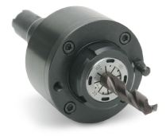

Live-Tool Drive Units
• Exsys/Eppinger – http://www.exsys-tool.com
• Parlec – http://www.parlec.com
• Heimatec – http://www.heimatecinc.com
• Benz – http://www.benz-inc.com
• MD Tooling - http://mdtooling.com
• MTS Driven Tools - http://www.mtsdriventools.co.uk
• WTO - http://www.wto-usa.com
• Von Ruden - http://www.vonruden.com
• Velocity - http://www.velocityproducts.com
• Holdwell - http://www.holdwell.com
• Global CNC - http://www.globalcnc.com

When commanding a spindle to rotate in the forward direction (M03, M143, M133), it will appear to move counter-clockwise (CCW), from the operators perspective.

Below is a visual aid showing the direction of the Main and Secondary Spindles on a DS machine, for turning (M3/M143), C-Axis rotation (M154), and Spindle Orientation (M19/M119).

From the illustration, we see that the following command will move the main spindle clockwise (from the perspective of the part face) by 90°

G54
M154
G00 C90. (ROTATES THE SPINDLE CLOCKWISE, IN OPERATOR VIEW)

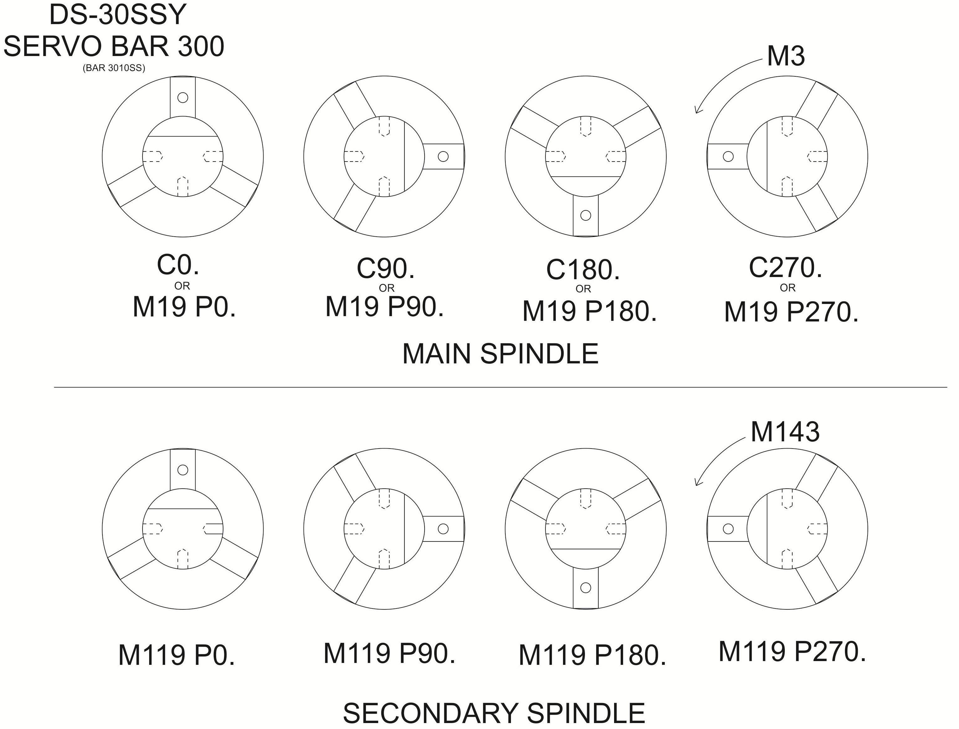

The following will command the live-tool to spin in the forward direction, at 2000 rpm:

G97 M133 P2000

We need to be very careful when using right-angled or extended live-tooling holders. These often contain gearing that will turn the tool in the opposite direction of the drive. Test all live-tool holders to make sure the tool is turning in the intended direction before cutting a part.

You can command the Secondary Spindle in the same manner:

G97 M143 P2000

While we may have a need to rotate the Secondary Spindle in this way, all machining on the second spindle must use a G14 Secondary Spindle Swap command. See the Dual Spindle section for more information. A brief example is shown below:

G14 (Spindle Swap On)
G97 M03 S2000
G15 (Spindle Swap Off)

All tapping speeds are commanded with an S value on the Haas Lathe, regardless of whether we are using the Main Spindle, the Secondary Spindle, or Live-Tooling.

